**Week 7 Solutions**

**React**

**11. ReactJS-HOL** .

Create a React Application “eventexamplesapp” to handle various events of the form elements in HTML.

The code and the folder structure is attached in the **Week 7/** **eventexamplesapp** folder

**Output :-**

**Chrome –** [**http://localhost:3000/**](http://localhost:3000/)

**The Page looks like this :-**

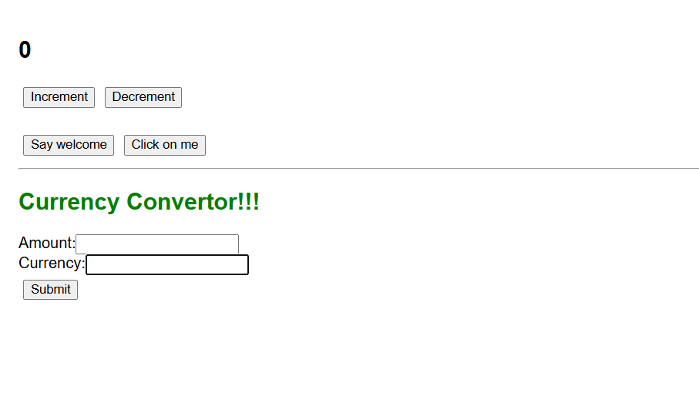

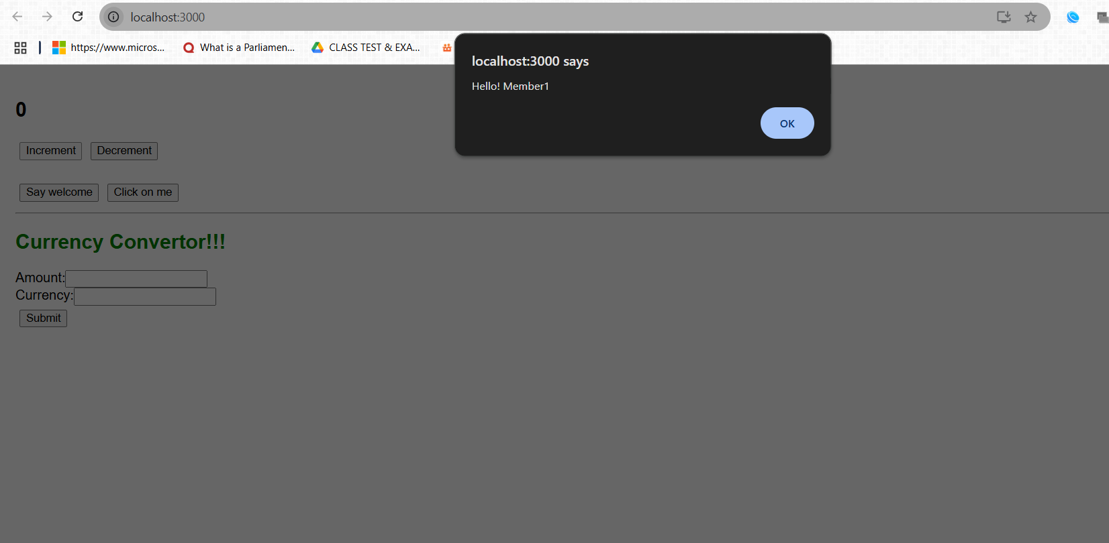

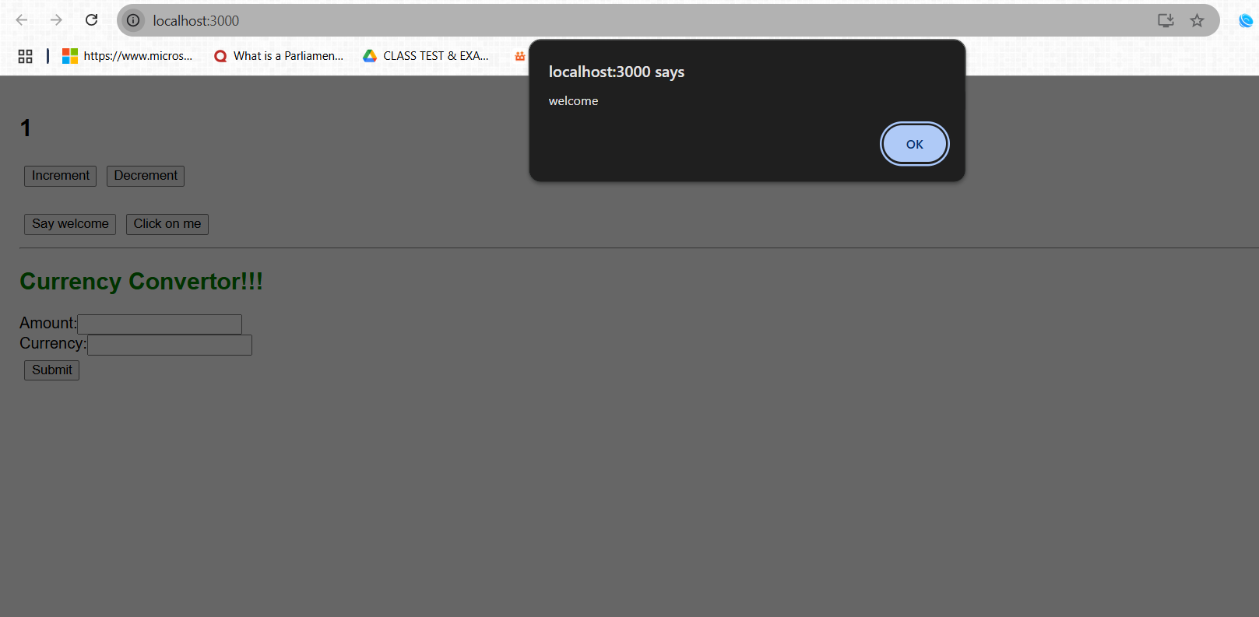

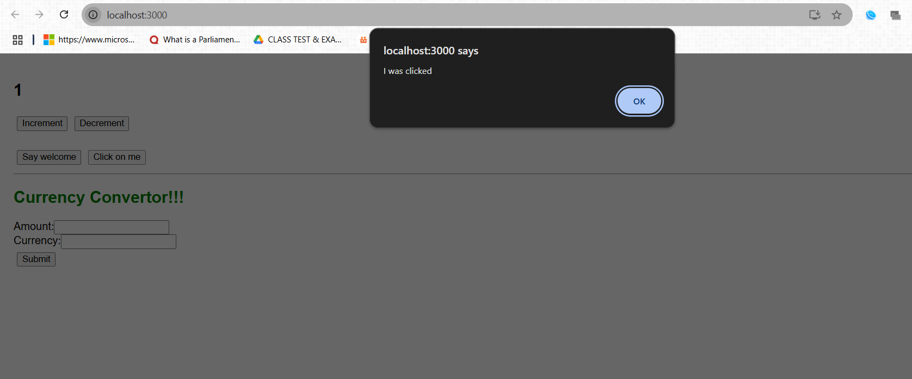

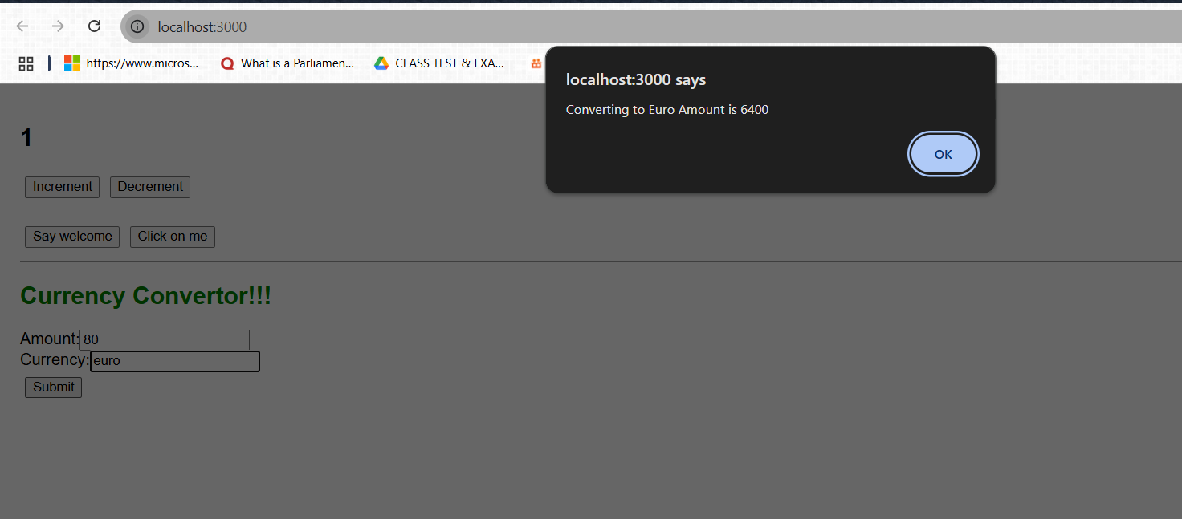

**The hands on file and folder is attached along with it**